Preparation:

1. Download the nrf Connect Bluetooth App:
   * 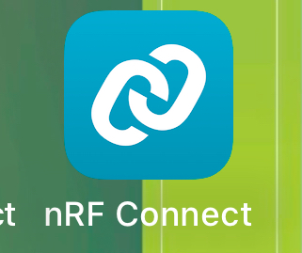
2. Open the app and connect the board to power. TRHe board should start advertising a connection for the phone as soon as it is active as below:
   * 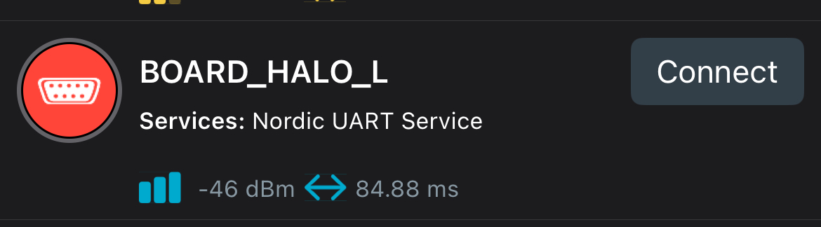
   * Note it should say Board_HALO_R for the GPS/right module. The red toggle switch will change the R or L mode.
3. Click on the Board_Halo_X device:
   * 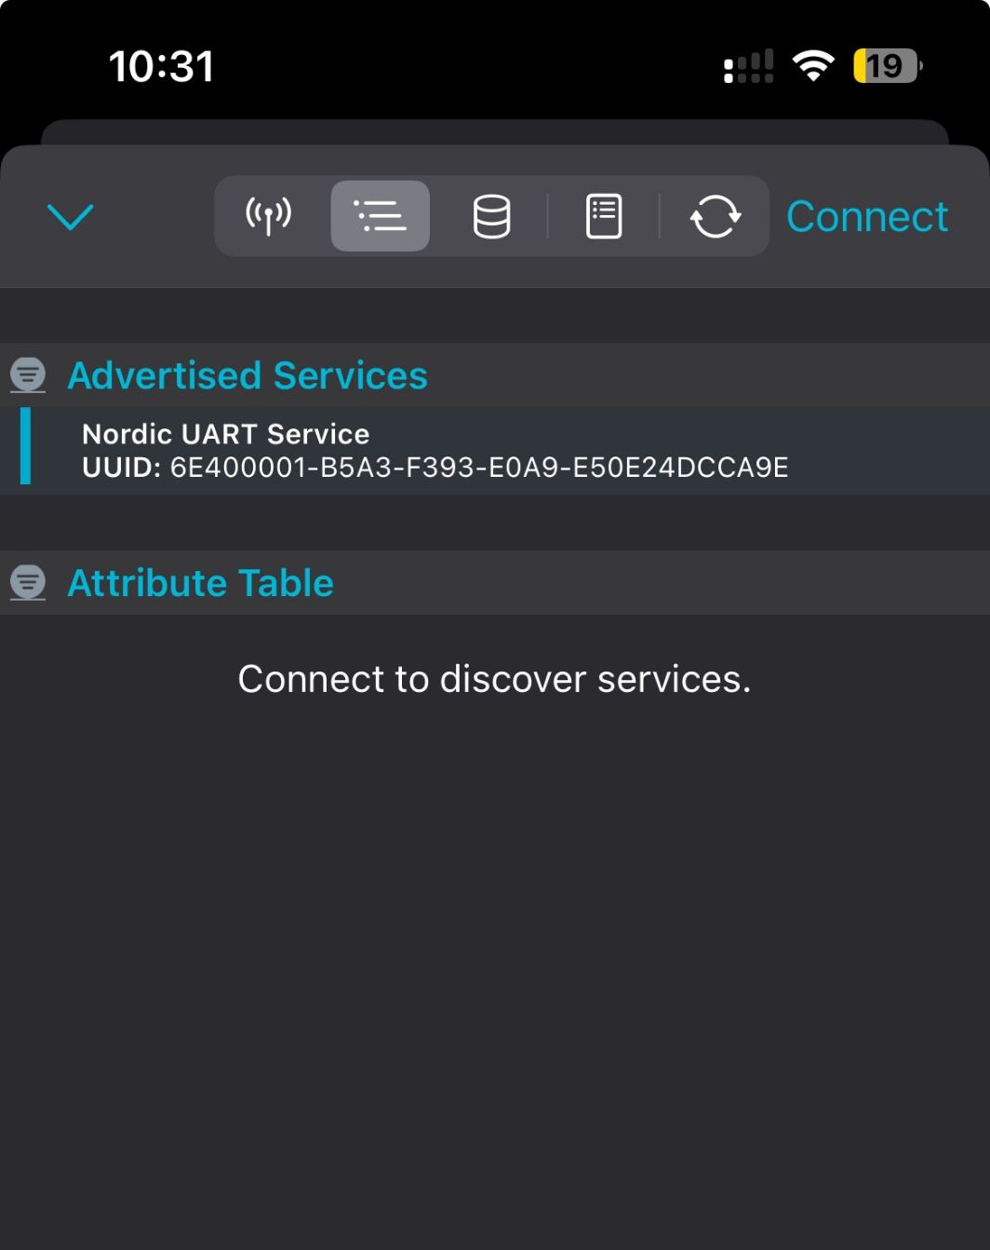
4. Connect to the device by hitting connect.
5. After Connection you should see a UART service as below in one of the sections:
   * 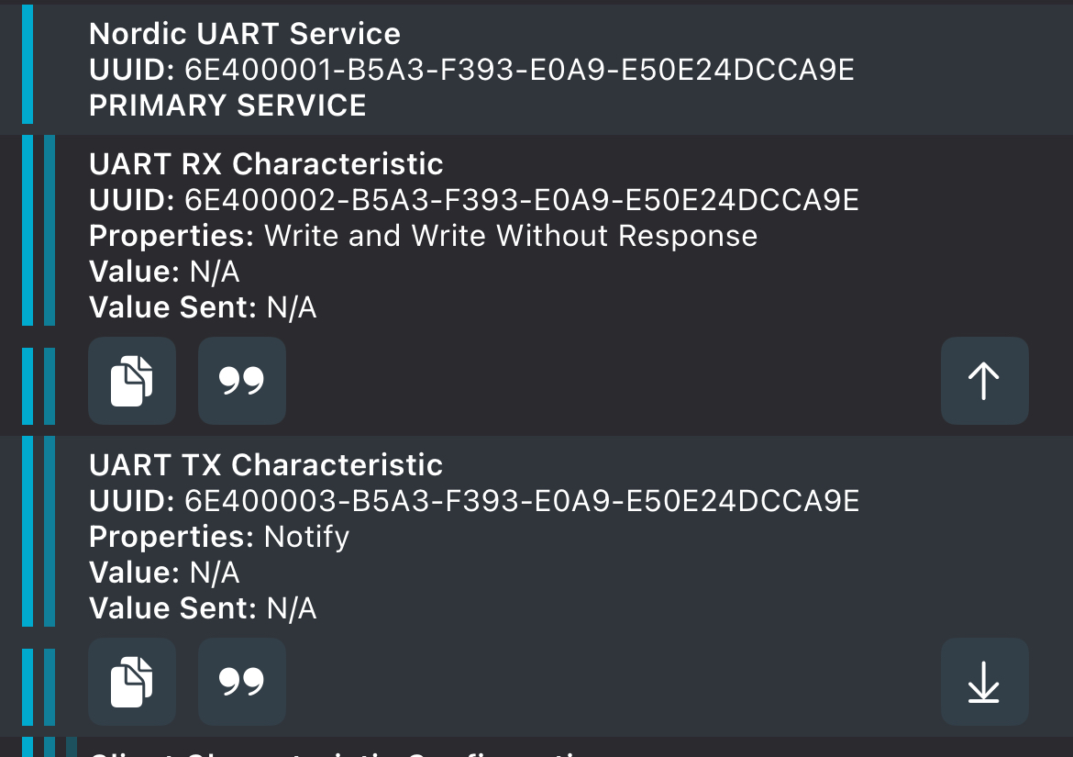
6. Click the down arrow on the TX Characteristic on the bottom right:
   * 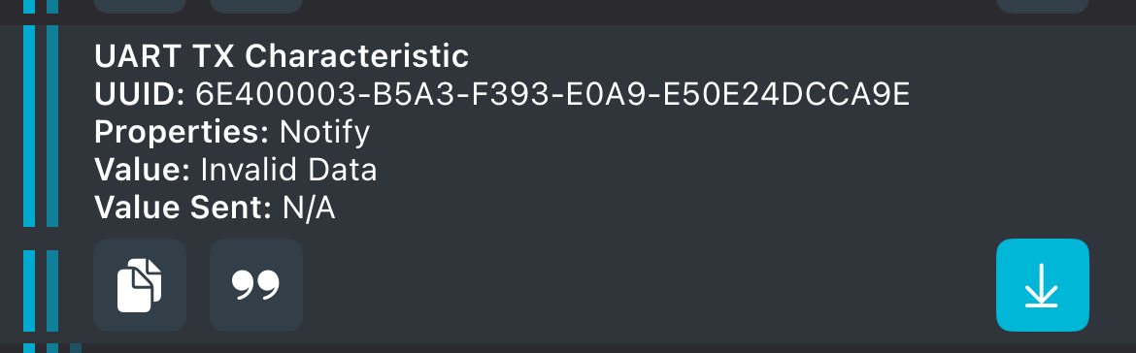
   * Note the Value should shown invalid data
7. Click the “ symbol and it should bring up the below:
   * 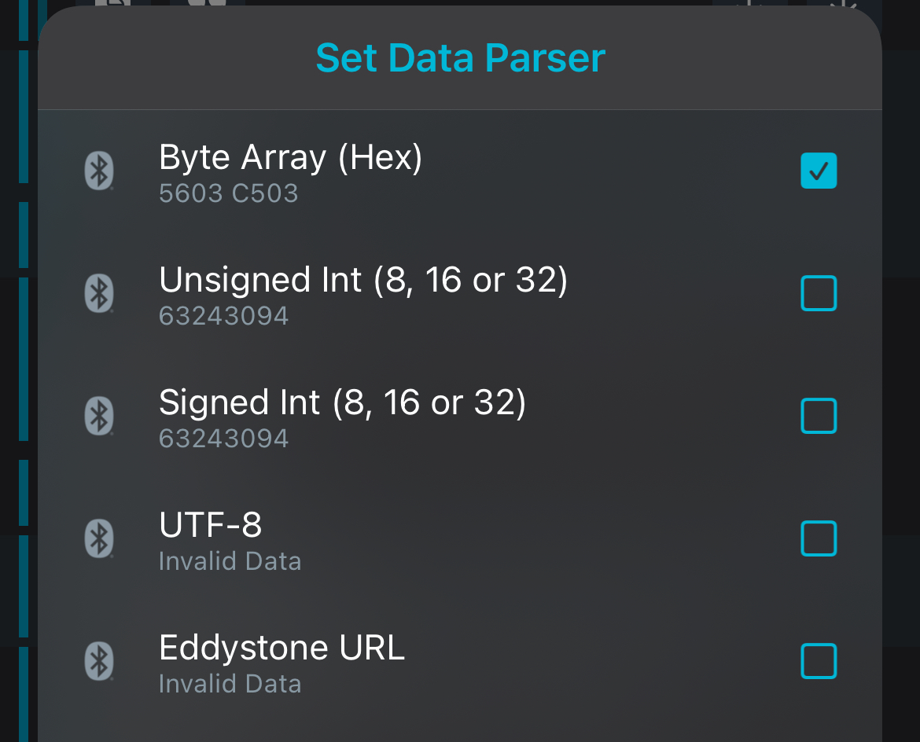
8. Click on the Byte Array (HEX) option
9. 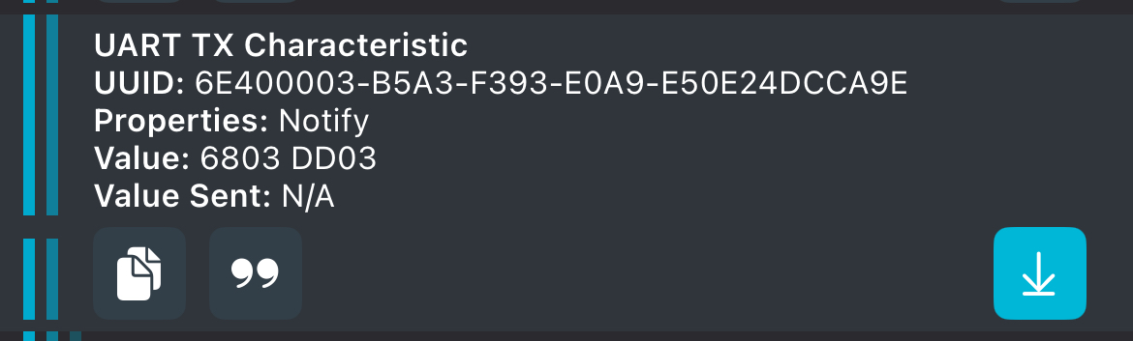
   * The Value section will have values now.
   * Note the gps version will have a lot more digits